Digital Scripting Assignmenty Two:

Endless runner pitch

My pitch for this semster is to create an isometric endless runner game. If I angle the camera from the upper right of the gamespace I will be able to create an isometric view. The player character will be automated and constantly moving in the same momentum whilst the platforms will be proceduraly generated using a set of 7 different tiles created in my 3D modeling lectures. Depending on the direction of the proceduraly generated plane players will have to swich through input keys to change the direction of the character in order to stay on route. Failing to stay on route will lead the player to losing the game.

Mechanics inspiration:

* Temple run (2011): proceduraly generated plane.
* Sonic the hedgehog (1991): Possible boss battles. (interups endless runner for battle)
* Cloud Path (Ketchapp) (2015): issometric endless runner.

[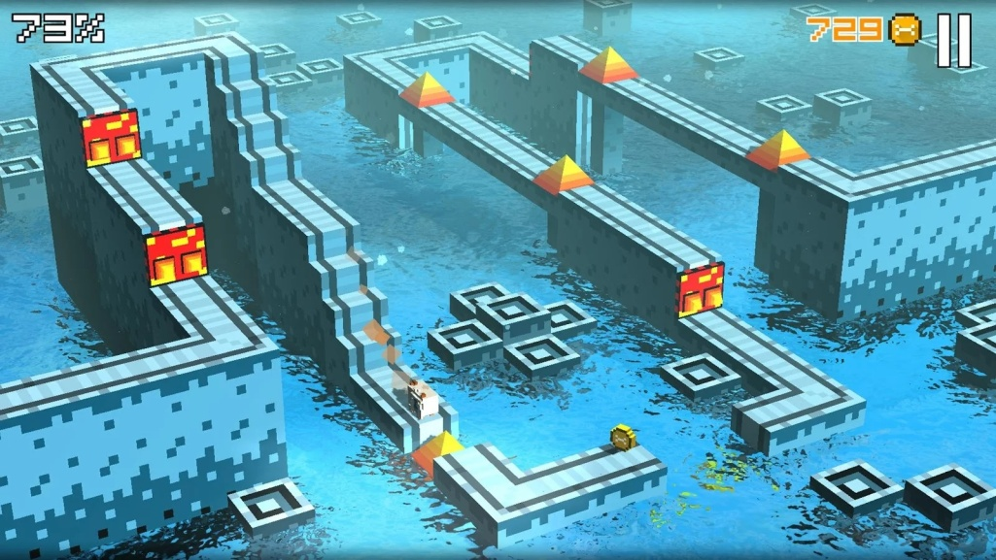](http://www.pocketgamer.co.uk/r/Android/Cliffy+Jump/news.asp?c=67180)Visual inspiration:

[](http://www.pocketgamer.co.uk/r/iPhone/Panic+Drop/review.asp?c=70973)

[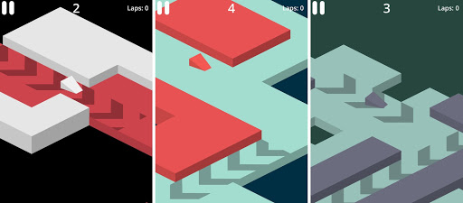](https://androidcommunity.com/blitz-racer-isometric-minimalist-arcade-racing-game-20141125/)

Blueprint tutorials need:

* Procedualry generated plane consisting of around seven separte tile types.
* Continuous velocity/movement.
* Pausing continous player movement.
* Collecting and storing distance data.

Refernces for images can be found as hyperlinks when hovering over images.